**Course Five**

# Regression Analysis: Simplifying Complex Data Relationships

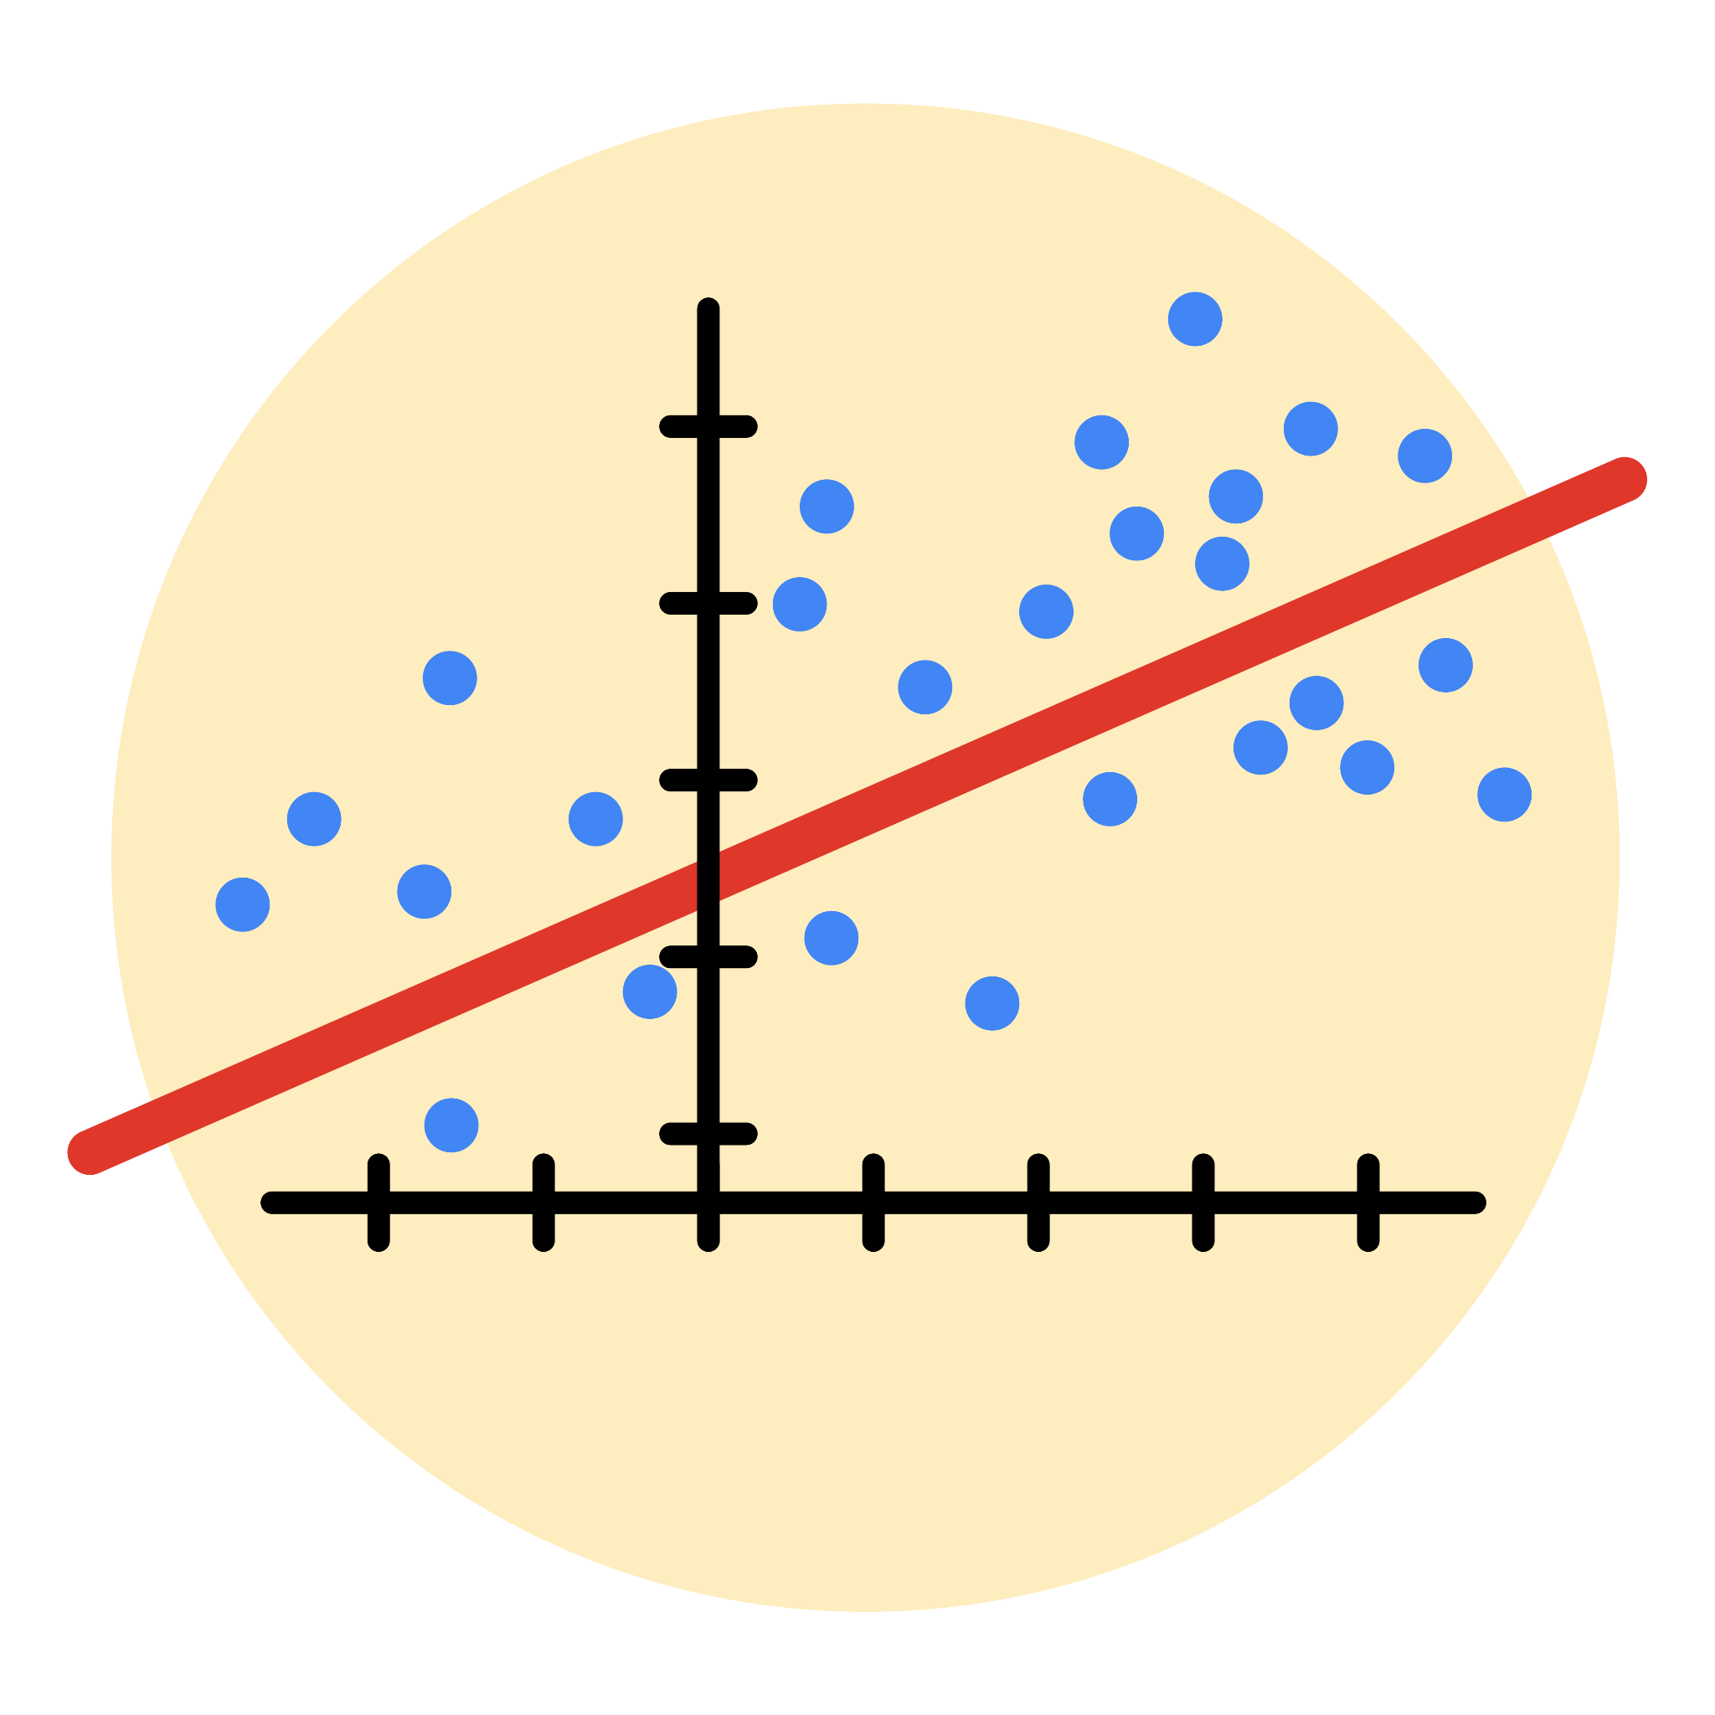

# Instructions

Use this PACE strategy document to record decisions and reflections as you work through this end-of-course project. As a reminder, this document is a resource that you can reference in the future, and a guide to help you consider responses and reflections posed at various points throughout projects.

# Course Project Recap

Regardless of which track you have chosen to complete, your goals for this project are:

* Complete the questions in the Course 5 PACE strategy document
* Answer the questions in the Jupyter notebook project file
* Build a multiple linear regression model
* Evaluate the model
* Create an executive summary for team members

# Relevant Interview Questions

Completing the end-of-course project will empower you to respond to the following interview topics:

* Describe the steps you would take to run a regression-based analysis
* List and describe the critical [assumptions of linear regression](https://www.digitalvidya.com/blog/assumptions-of-linear-regression/)
* What is the primary difference between R2 and adjusted R2?
* How do you interpret a Q-Q plot in a linear regression model?
* What is the bias-variance tradeoff? How does it relate to building a multiple linear regression model? Consider variable selection and adjusted R2.

**Reference Guide**

This project has seven tasks; the visual below identifies how the stages of PACE are incorporated across those tasks.

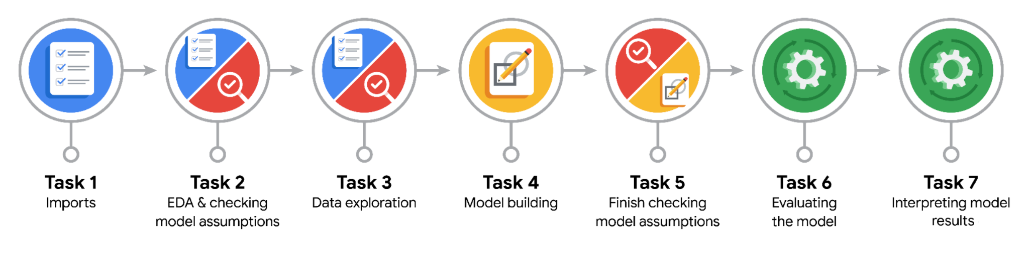

**Data Project Questions & Considerations**

**PACE: Plan Stage**

* Who are your external stakeholders for this project?

The external stakeholders for this project are the NYC Taxi and Limousine Commission (New York City TLC) and the data consulting firm Automatidata.

* What are you trying to solve or accomplish?

The goal of the project is to build a multiple linear regression model to predict taxi fare amounts using existing data collected by the NYC Taxi and Limousine Commission. The aim is to develop an accurate model that can effectively predict fares based on various input features, providing valuable insights and a tool for fare estimation.

* What are your initial observations when you explore the data?

Some initial observations when exploring the data include:

1. The dataset contains information about various variables such as passenger count, trip distance, pickup/dropoff locations, payment type, and fare amount.

2. There are missing values in some columns, which may require data cleaning or imputation.

3. Some variables, such as trip distance and duration, show a wide range of values, indicating potential variability in the fare amounts.

4. Categorical variables like VendorID and store_and_fwd_flag may need to be converted into numerical or binary representations for analysis.

5. There may be correlations between certain variables, such as trip distance and fare amount, which could be explored further.

6. The presence of outliers in certain columns, such as fare amount, may require consideration during the modeling process.

These initial observations provide insights into the nature of the data and guide further analysis and preprocessing steps

* What resources do you find yourself using as you complete this stage?

As I complete this stage, I find myself using various resources to aid in the analysis and modeling process. Some of the key resources include:

1. Pandas documentation: The official documentation for the Pandas library provides detailed information on how to manipulate and analyze the dataset, including data cleaning, aggregation, and transformation operations.

2. NumPy documentation: The NumPy documentation is useful for understanding and working with numerical operations and arrays, which are often required for data manipulation and mathematical calculations.

3. Matplotlib and Seaborn documentation: These libraries' documentation helps in creating visualizations to explore the data, understand distributions, and identify patterns or relationships between variables.

4. Scikit-learn documentation: The Scikit-learn documentation is essential for understanding and implementing machine learning algorithms, including multiple linear regression, as well as evaluating model performance using various metrics.

5. Stack Overflow: This online community platform is a valuable resource for finding solutions to specific coding challenges or troubleshooting issues that may arise during the analysis and modeling process.

6. Python programming resources: General Python programming resources, such as Python.org and various online tutorials, are helpful for refreshing and enhancing my knowledge of Python programming concepts and syntax.

These resources collectively provide guidance, reference materials, and solutions to challenges encountered during the data analysis and modeling stage.

**PACE: Analyze Stage**

* What are some purposes of EDA before constructing a multiple linear regression model?

some purposes of EDA before constructing a multiple linear regression model are as follows:

1. Identify patterns and relationships between variables to gain insights into the data.

2. Assess the quality and completeness of the data to ensure it meets the requirements for regression analysis.

3. Detect and handle missing values, outliers, or data inconsistencies that can affect the accuracy of the regression model.

4. Explore the distributions and characteristics of the variables to determine if any transformations are needed.

5. Identify potential multicollinearity issues between independent variables.

6. Evaluate the linearity assumption between the dependent variable and independent variables.

7. Assess the appropriateness of the model assumptions, such as normality and constant variance.

8. Identify any interactions or nonlinear relationships that may need to be considered in the model.

9. Determine which variables have the most significant impact on the dependent variable.

10. Validate the model's performance and assess its predictive power through visualizations and statistical metrics.

* Do you have any ethical considerations in this stage?

At this stage, there are several ethical considerations to keep in mind:

1. Privacy: Ensure that the data used for modeling and analysis is anonymized and complies with privacy regulations. Protect the personal information of individuals, including passengers and drivers, and handle the data in a responsible and secure manner.

2. Bias and Fairness: Assess the potential bias in the data and model predictions. Pay attention to any discriminatory patterns or disparate impacts on certain groups based on attributes like race, gender, or socioeconomic status. Take steps to mitigate and address these biases to ensure fairness in decision-making.

3. Transparency and Explainability: Provide clear explanations of the model's predictions and the factors influencing them. Avoid using overly complex or opaque models that make it difficult for stakeholders to understand and question the results. Foster transparency and open dialogue around the model's limitations, assumptions, and potential biases.

4. Accountability: Establish processes for accountability and oversight in the use of the model. Monitor the model's performance over time and conduct regular audits to identify any unintended consequences or ethical concerns that may arise. Take responsibility for the impact of the model's predictions and actively seek feedback from stakeholders.

5. Data Quality and Validation: Ensure the accuracy and reliability of the data used for modeling. Validate the data sources, check for any data quality issues or anomalies, and take steps to address them. Relying on high-quality data is essential for producing trustworthy and ethical results.

6. Use of Models for Decision-making: Understand the limitations of the models and avoid over-reliance on automated decision-making without human oversight. Use the models as tools to support decision-making, but maintain human judgment and ethical considerations in the final decisions.

7. Informed Consent: If the analysis involves sensitive or personal data, ensure that appropriate informed consent procedures are followed. Obtain consent from individuals for the collection, use, and analysis of their data in a manner that respects their autonomy and privacy.

By considering these ethical considerations, the team can ensure that the modeling process and its outcomes are conducted with integrity, fairness, and respect for individuals' rights and well-being.

**PACE: Construct Stage**

* Do you notice anything odd?

Based on the dataset and the observations made during the activity, there are a few odd or unusual patterns that can be inferred:

1. Fare Amount Outliers: The dataset contains some extreme values for fare amounts, including values that are significantly higher than the majority of fares. These outliers can have a significant impact on the analysis and modeling process, and it's important to handle them appropriately, such as by applying outlier detection and treatment methods.

2. Maximum Imputed Fare Amount: During the data preprocessing stage, a maximum value of $62.50 was imputed for fare amounts that were previously identified as outliers. This maximum imputed value indicates that all former outliers are now assigned a fare amount of $62.50. This is an unusual pattern and can introduce some limitations or biases in the analysis if not carefully addressed.

3. Constant Fare Amount: There are instances where trips have the same fare amount, such as $52. This could indicate that certain fare amounts were standardized or fixed for specific trip scenarios or fare calculation rules. However, it's important to further investigate these cases to ensure that this constant fare amount is not an artifact of the data collection or preprocessing process.

These odd patterns highlight the need for thorough data exploration, preprocessing, and careful consideration of potential biases or anomalies in the dataset. It's important to address these odd patterns appropriately to ensure the accuracy and reliability of the subsequent analysis and modeling stages.

* Can you improve it? Is there anything you would change about the model?

The model performance metrics obtained are generally good, indicating that the model has captured a significant portion of the variance in the target variable and has low error measures. The R^2 value of 0.8619 indicates that approximately 86.19% of the variance in the fare amount can be explained by the model. The RMSE value of 3.8746 indicates that, on average, the predicted fare amount deviates by approximately $3.87 from the actual fare amount.

* What resources do you find yourself using as you complete this stage?

The following are available resources to use to improve the model’s performace. Here are a few suggestions to potentially enhance the model:

1. Feature Engineering: Explore additional features or transform existing features to capture more relevant information. For example, consider creating interaction terms or polynomial features to capture nonlinear relationships between the predictors and the fare amount.

2. Outlier Handling: Investigate and refine the approach to handling outliers in the fare amount. Instead of simply imputing a maximum value, consider using more sophisticated outlier detection techniques and consider different strategies for handling outliers, such as Winsorization or removing extreme values.

3. Model Selection: Evaluate alternative regression models, such as Ridge Regression, Lasso Regression, or Random Forest Regression, to assess if they can provide better performance compared to the linear regression model.

4. Cross-Validation: Utilize cross-validation techniques, such as k-fold cross-validation, to obtain more robust and reliable performance metrics for the model. This helps to assess the generalization of the model beyond the specific training and test dataset split.

5. Further Data Exploration: Dig deeper into the data to identify other potential patterns or relationships that can improve the model's performance. Consider exploring interactions between variables, examining the effect of categorical variables in more detail, or identifying any missing or erroneous data that may need to be addressed.

Overall, while the current model has performed well, implementing these suggestions can potentially lead to further improvements in accuracy and robustness. It is important to iterate and refine the model based on ongoing evaluation and feedback from stakeholders and domain experts.

**PACE: Execute Stage**

* What key insights emerged from your model(s)?

From the multiple linear regression model, several key insights emerged:

1. Mean distance has the largest positive effect on the fare amount. This suggests that longer distances traveled result in higher fare amounts, which is intuitive.

2. Mean duration also has a positive effect on the fare amount, although the effect is relatively smaller compared to mean distance. This indicates that longer durations of trips are associated with slightly higher fare amounts.

3. The hour (rush_hour) of the day has a positive effect on the fare amount, although the effect is again relatively small. This suggests that certain hours may be associated with slightly higher fares, potentially due to factors like increased demand during peak hours.

4. Passenger count and VendorID have smaller coefficients and therefore have a relatively smaller effect on the fare amount. These variables may still contribute to the overall prediction but to a lesser extent compared to mean distance, mean duration, and hour.

Overall, the model provides insights into the factors that influence taxi fare amounts, with mean distance being the most significant factor. These insights can be valuable for understanding fare dynamics and making predictions for future taxi trips.

* What business recommendations do you propose based on the models built?

Based on the models built, the following business recommendations can be proposed:

1. Pricing Strategy: The model indicates that the distance of the trip has the largest impact on the fare amount. Therefore, the company could consider implementing a dynamic pricing strategy based on distance, where longer trips are priced slightly higher. This can help optimize revenue and align fares with the value provided.

2. Time-based Pricing: The hour of the day also has a small but noticeable effect on the fare amount. The company can explore implementing time-based pricing, where fares are adjusted during peak hours to reflect increased demand and potentially higher operating costs. This can help balance supply and demand while maximizing profitability.

3. Customer Segmentation: The model suggests that passenger count and the vendor ID have relatively smaller effects on fare amounts. However, these variables still contribute to the overall prediction. The company can segment customers based on these variables and tailor marketing strategies or loyalty programs accordingly. For example, offering discounts or incentives to frequent riders or groups traveling together may help attract and retain customers.

4. Efficiency Optimization: The model's focus on mean duration implies that optimizing trip durations can have a positive impact on fare amounts. The company can explore strategies to improve efficiency, such as optimizing routing algorithms or incentivizing drivers to minimize idle time. This can result in shorter trip durations, increased customer satisfaction, and potentially higher fare amounts.

5. Continuous Model Monitoring: As the model may require periodic updates due to changes in market dynamics or other factors, it is recommended to implement a system for continuous model monitoring and validation. This will ensure that the model's performance remains reliable and up-to-date, allowing for timely adjustments and improvements.

These business recommendations aim to leverage the insights gained from the models to enhance revenue generation, customer satisfaction, and operational efficiency in the taxi service.

* To interpret model results, why is it important to interpret the beta coefficients?

Interpreting the beta coefficients in a model is important because they provide information about the magnitude and direction of the impact that each independent variable has on the dependent variable. Here are a few reasons why interpreting beta coefficients is important:

1. Magnitude of Effect: Beta coefficients indicate the magnitude of the effect that a unit change in the independent variable has on the dependent variable, while holding other variables constant. By interpreting the beta coefficients, we can understand the relative importance of different variables in influencing the outcome. For example, a higher magnitude coefficient suggests a stronger impact on the dependent variable.

2. Direction of Effect: The sign of the beta coefficient (positive or negative) indicates the direction of the effect of the independent variable on the dependent variable. Positive coefficients indicate a positive relationship, meaning that an increase in the independent variable leads to an increase in the dependent variable. Negative coefficients indicate a negative relationship, where an increase in the independent variable leads to a decrease in the dependent variable. Understanding the direction of the effect helps in making informed decisions and understanding the relationships within the data.

3. Variable Importance: Beta coefficients help in identifying the most influential variables in the model. Variables with larger coefficients have a larger impact on the outcome and are considered more important. This information can guide decision-making and resource allocation in areas that have the most significant influence on the outcome.

4. Model Comparison: Beta coefficients provide a basis for comparing the impact of different variables in the model. By comparing the magnitudes and directions of the coefficients, we can assess the relative importance and influence of different variables on the outcome. This comparison helps in prioritizing variables and understanding their contribution to the model's predictive power.

Overall, interpreting the beta coefficients allows us to gain insights into the relationships between the independent and dependent variables in the model, understand the importance of different variables, and make informed decisions based on the model results.

* What potential recommendations would you make?

Based on the findings of the model, I would make the following potential recommendations:

1. Fare Pricing Strategy: The model indicates that both mean_distance and mean_duration have a positive impact on the fare amount. To optimize revenue, the taxi company could consider implementing a fare pricing strategy that takes into account the distance and duration of the trip. This could involve adjusting the fare rates based on predetermined thresholds to accurately reflect the cost associated with longer trips.

2. Service Improvement for Long-Distance Trips: Since the mean_distance variable has a strong positive coefficient, it suggests that long-distance trips contribute significantly to the fare amount. The taxi company could focus on providing excellent service and ensuring passenger satisfaction for long-distance rides. This could include amenities, comfortable vehicles, and well-trained drivers to enhance the overall customer experience and justify the higher fare amounts.

3. Vendor Performance Evaluation: The negative coefficient for the VendorID variable indicates that certain vendors may offer slightly lower fares compared to others. It would be beneficial for the taxi company to evaluate the performance of different vendors and identify any factors that may contribute to the observed differences in fare amounts. This evaluation could help optimize vendor partnerships and negotiate fare agreements to ensure competitiveness while maintaining profitability.

4. Time-based Pricing: The hour variable has a positive coefficient, suggesting that certain hours of the day may correspond to higher fare amounts. The taxi company could consider implementing time-based pricing, where fares are adjusted during peak hours or periods of high demand. This strategy can help optimize revenue generation during busy times and incentivize drivers to be available during those periods.

5. Further Analysis: Although the model has provided valuable insights, additional analysis could be conducted to explore other potential factors that might influence fare amounts. This could involve investigating the impact of additional variables such as weather conditions, special events, or traffic congestion on fare pricing. Such analysis would provide a more comprehensive understanding of the factors influencing fare amounts and allow for more informed decision-making.

It's important to note that these recommendations should be further evaluated and tailored to the specific context and goals of the taxi company. Close collaboration with stakeholders and continuous monitoring of the model's performance will help refine these recommendations and ensure their effectiveness in practice.

* Do you think your model could be improved? Why or why not? How?

Yes, there is always room for improvement in a model. While the current model provides reasonably good results with a high coefficient of determination (R^2) and relatively low error metrics, there are several potential avenues for improvement:

1. Feature Engineering: The current model uses a limited set of features such as mean_distance, mean_duration, hour, passenger_count, and VendorID. By incorporating additional relevant features, such as weather conditions, traffic data, or demographic information, the model could capture more nuances and improve its predictive power.

2. Outlier Handling: The current model does not explicitly address outliers in the dataset. Outliers can significantly impact the model's performance and predictions. Applying robust outlier detection and handling techniques, such as Winsorization or removing extreme values, could enhance the model's accuracy.

3. Non-Linear Relationships: The current model assumes a linear relationship between the features and the target variable. However, there might exist non-linear relationships that could be better captured using advanced regression techniques, such as polynomial regression or non-linear regression algorithms. Exploring these approaches could lead to improved model performance.

4. Model Selection and Tuning: Although linear regression is a common and interpretable approach, there are other regression algorithms that could potentially yield better results for this specific dataset. Techniques like Ridge regression or Gradient Boosting Regression could be explored and compared to the current model to determine the best fit for the data.

5. Cross-Validation and Regularization: To ensure the robustness of the model, implementing cross-validation techniques, such as k-fold cross-validation, can help assess its performance on different subsets of the data. Additionally, applying regularization techniques like L1 or L2 regularization can help mitigate overfitting and improve the model's generalization capability.

6. Data Quality and Quantity: The quality and quantity of data play a crucial role in model performance. Further data cleaning, ensuring data consistency, and collecting more data could improve the model's accuracy and generalizability.

It's important to iteratively refine and enhance the model based on feedback, continuous evaluation, and incorporating domain expertise. Regular monitoring of model performance and keeping up with advancements in regression modeling techniques will contribute to ongoing improvements.

* What business/organizational recommendations would you propose based on the models built?

Based on the models built, here are some business/organizational recommendations:

1. Fare Estimation Tool: Develop a fare estimation tool using the regression model to provide customers with an estimated fare for their taxi rides. This can help improve transparency and customer satisfaction by setting appropriate expectations regarding the fare.

2. Surge Pricing Strategy: Utilize the insights from the regression model, particularly the coefficient values, to optimize surge pricing strategies during peak demand periods. By considering factors such as distance, duration, and time of day, the organization can implement dynamic pricing models that maximize revenue while ensuring fairness to customers.

3. Resource Allocation: Use the regression model to forecast demand patterns based on the time of day and other relevant factors. This information can assist in optimizing resource allocation, such as the number of available taxis and drivers, to meet customer demand effectively and minimize waiting times.

4. Promotional Campaigns: Leverage the regression model's findings to design targeted promotional campaigns. For example, if the model identifies that fare amounts are influenced by the hour of the day, launch time-specific discounts or offers during periods of lower demand to incentivize customers to take taxis.

5. Service Planning and Optimization: Analyze the coefficients of the regression model to identify the factors that have the most significant impact on fare amounts, such as mean_distance and mean_duration. Use this information to optimize service planning, such as identifying high-demand areas or time periods for potential expansion or service adjustments.

6. Customer Segmentation: Explore customer segmentation based on the regression model's insights to understand different fare preferences and behaviors. This can help tailor marketing strategies, loyalty programs, and service offerings to specific customer segments, enhancing customer satisfaction and loyalty.

7. Performance Monitoring and Quality Control: Continuously monitor the model's performance metrics, such as R^2, MSE, and RMSE, to ensure the model's accuracy and reliability. Regularly update and retrain the model using new data to account for evolving patterns and trends in taxi fares.

It is important to note that these recommendations should be further evaluated and aligned with the specific goals, constraints, and business context of the organization. Regular monitoring and collaboration between data analytics teams and business stakeholders will facilitate the implementation and refinement of these recommendations.

* Given what you know about the data and the models you were using, what other questions could you address for the team?

Based on the data and models used, here are some additional questions that could be addressed by the team:

1. Fare Variation Analysis: Investigate the factors contributing to the variations in fare amounts for similar trip distances and durations. Are there any specific factors not captured by the current model that could explain these variations? This analysis could help identify potential additional variables or data sources to improve the model's accuracy.

2. Outlier Detection: Analyze the residuals and identify any significant outliers in the data. Understand the characteristics of these outliers and assess whether they represent valid data points or potential data errors. This analysis can provide insights into the robustness of the model and guide decision-making regarding the treatment of outliers.

3. Feature Importance: Assess the relative importance of different features in predicting fare amounts. Rank the features based on their influence and explore how the model's performance changes when certain features are excluded or given more weight. This analysis can provide insights into the key drivers of fare amounts and guide feature selection or engineering efforts.

4. Temporal Analysis: Explore the temporal patterns and trends in taxi fares over different time scales (e.g., daily, weekly, monthly). Identify any seasonality or long-term trends in fare amounts and evaluate how well the model captures these patterns. This analysis can help improve forecasting capabilities and inform business decisions related to pricing and resource allocation.

5. Geospatial Analysis: Incorporate geospatial data, such as pickup and drop-off locations, to understand the impact of specific areas or routes on fare amounts. Identify areas with high fare variability or explore the relationship between fare amounts and factors like proximity to landmarks, airports, or popular destinations. This analysis can provide insights for targeted marketing campaigns or service optimization in specific geographic regions.

6. Model Comparison: Compare the performance of the current multiple linear regression model with other advanced modeling techniques, such as random forests, gradient boosting, or neural networks. Evaluate the strengths and limitations of different models in predicting fare amounts and identify opportunities for model improvement or ensemble approaches.

7. Customer Segmentation Analysis: Conduct customer segmentation based on fare preferences, trip characteristics, or other relevant variables. Analyze the distinct behaviors and preferences of different customer segments and explore personalized pricing strategies or service offerings for each segment. This analysis can enhance customer targeting, satisfaction, and revenue generation.

These questions can help the team gain further insights from the data, improve the existing models, and explore additional avenues for data-driven decision-making.

* Do you have any ethical considerations at this stage?

Yes, there are several ethical considerations to be aware of at this stage of the project. Here are some personalized considerations based on the project activity and observations made from the dataset:

1. Privacy and Confidentiality: It is essential to ensure the privacy and confidentiality of the data collected by the NYC Taxi and Limousine Commission (TLC). As the data contains sensitive information about passengers and their travel patterns, it is crucial to handle the data with care and adhere to data protection regulations and policies. Any sharing or dissemination of the data should be done in a secure and anonymized manner.

2. Fairness and Bias: The model should be evaluated for potential biases and ensure fairness in the predictions and outcomes. It is important to assess whether the model introduces any unintended biases based on factors such as passenger demographics, pickup or drop-off locations, or trip characteristics. Any biases identified should be addressed and mitigated to ensure equitable and unbiased fare predictions.

3. Transparency and Explainability: The model's predictions and decision-making process should be transparent and explainable to stakeholders. It is crucial to provide clear and interpretable insights about the factors influencing fare amounts and the rationale behind the model's predictions. This transparency helps build trust with stakeholders and allows for better understanding and scrutiny of the model's outcomes.

4. Data Integrity and Quality: Ensuring the accuracy and integrity of the data used for model training and evaluation is essential. It is important to identify and address any data quality issues, such as missing values, outliers, or data inconsistencies, to maintain the integrity of the model's results. Additionally, thorough documentation of data preprocessing steps, feature engineering techniques, and model selection criteria helps maintain transparency and reproducibility.

5. Ethical Use of Predictions: The predictions and insights generated by the model should be used in an ethical manner. Care should be taken to avoid any misuse of the model's outcomes, such as unfair pricing strategies, discriminatory practices, or invasion of privacy. The predictions should be used for legitimate and lawful purposes, adhering to ethical guidelines and regulations.

6. Ongoing Monitoring and Evaluation: Continuous monitoring and evaluation of the model's performance and ethical implications are crucial. Regularly assessing the model's accuracy, fairness, and impact on stakeholders ensures that any emerging ethical concerns can be addressed promptly. Iterative improvement of the model based on feedback and monitoring results helps maintain ethical standards throughout the project.

By considering these ethical considerations and actively addressing them throughout the project, the team can ensure responsible and ethical use of data and models, promote fairness and transparency, and uphold the trust of stakeholders.